24-9-2015

Mariano Orozco García

Procesamiento de señales biológicas, 3BM4

Tovar Corona Blanca

Fourier Transform

Practice 2

***Practice 2 – Fourier Transform***

***INTRODUCTION:***

We can extract information from a signal in two different domains that give us different approaches to analyze that data. The first one and most common way is the time domain. Mostly, when we measure the signal we obtain this kind of interpretation because we do samplings along different time gaps. From the time domain we can extract the amplitude of the signal at any given time. The alternative way of extracting information from the signal is in the frequency domain. In the frequency domain we can primary extract the principal frequencies that the signal possess, is much more important in its practical applications than in the physical implications. This version of the data is called Fourier analysis because we used Fourier Transform to convert a time domain signal in a frequency domain signal.

***Fourier Transform:***

The Fourier Transform (FT), denominated this way for Joseph Fourier, converts signals from time to frequency domain. Given a signal *F(t)* whether is periodic or not, a complete description of F(t) can be given using sines and cosines. If *F(t)* is not periodic it requires all frequencies to be present if it is to be synthesized accurately. A non-periodic function may be thought of as a limiting case of a periodic one, where the period tends to infinity, and consequently the fundamental frequency tends to zero. Using the Fourier to represent any signal where the summation sign is replaced by an integral sign, we find that:

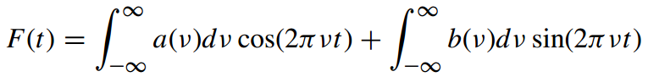

or, equivalently,

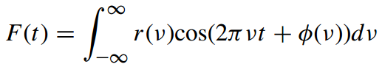

or,

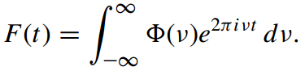

***GENERAL PROPUSE:***

To calculate and analyze different responses in time and frequency domain, understanding what kind of information we can obtain for each of them as well as understanding how to work with this data in a software environment.

***PROCEDURE:***

The practice consists in analyzing the following functions in time and frequency domain with the desired parameters:

* + - * 1. , A = 1, f0 = 50 Hz, Fs = 1000 Hz;
        2. $x\left(t\right)=\operatorname{Arect}{(\frac{t}{T})}$, A = 1, T = 2 s, Fs = 100 Hz;
        3. $x\left(t\right)=Ae^{-at}$, t > 0, A = 1, a = 5, Fs = 10 Hz;
        4. , A = 2, B = 1, f1 = 80 Hz, f2 = 120 Hz, Fs = 1200;
        5. $x\left(t\right)=\operatorname{Atri}{(\frac{t}{T})}$, A = 1, T = 1 s, Fs = 100 Hz;

We will make the analysis by hand and with the help of the software MATLAB to compare both results: the theoretical (FT) and the one that we obtain using the FFT function. Then we will plot the signal in time and frequency domain for the results that we obtain in the FFT case.

To implement this we use the following code:

function [] = Practice2( )

% Calculate the FT of the following functions:

Data = {};

% 1) x(t) = A*sin(2*pi*f0*t); f0 = 50 Hz; Fs = 1000 Hz;

Fs = 1000;

f0 = 50;

t = 0:1/Fs:0.2;

x = sin(2*pi*f0*t);

[f,X] = fourierVector(x,Fs);

Data = save(t,x,f,X,Fs,Data);

% 2) x(t) = A*rect(t/T); Fs = 100 Hz;

Fs = 100;

T = 2;

[t,x] = rect(T,Fs);

[f,X] = fourierVector(x,Fs);

Data = save(t,x,f,X,Fs,Data);

% 3) x(t) = A*exp(-a*t); Fs = 10 Hz;

Fs = 10;

a = 5;

t = 0:1/Fs:4;

x = exp(-a*t);

[f,X] = fourierVector(x,Fs);

Data = save(t,x,f,X,Fs,Data);

% 4) x(t) = A*sin() + sin(); f01 = 80 Hz; f02 = 120 Hz; Fs = propose;

Fs = 1200;

t = 0:1/Fs:0.1;

f1 = 80;

f2 = 120;

x = 2*sin(2*pi*f1*t) + sin(2*pi*f2*t);

[f,X] = fourierVector(x,Fs);

Data = save(t,x,f,X,Fs,Data);

% 5) x(t) = A*tri(t/T); Fs = 100 Hz;

Fs = 100;

T = 1;

[t,x] = tri(T,Fs);

[f,X] = fourierVector(x,Fs);

Data = save(t,x,f,X,Fs,Data);

% Graphics:

limx = [150,20,5,400,5];

for i = 1:size(Data,1)

figure

subplot(2,1,1)

plot(Data{i,1},Data{i,2})

xlabel('Time (s)')

ylabel('Amplitude (v)')

ylim([1.1*min(Data{i,2}),1.1*max(Data{i,2})])

title(['Time domain at Fs = ',num2str(Data{i,5})])

subplot(2,1,2)

plot(Data{i,3},Data{i,4})

xlabel('Frequency (Hz)')

xlim([0,limx(i)])

ylabel('Amplitude (v)')

ylim([0,1.1*max(Data{i,4})])

title(['Frequency domain at Fs = ',num2str(Data{i,5})])

end

end

We also created this complementary functions that are used in the code above:

function [f,X] = fourierVector(x,Fs)

% To obtain absolute positive values of the fourier transform of x

% it also obtains the corresponding frequency vector

X = fft(x);

Ie = floor(length(X)/2);

X = abs(X(1:Ie))/length(X);

f = (0:Ie-1)*((Fs/2)/(Ie-1));

end

function [Data] = save(t,x,f,X,Fs,Data)

% Stores data in a cell

l = size(Data,1);

Data{l+1,1} = t;

Data{l+1,2} = x;

Data{l+1,3} = f;

Data{l+1,4} = X;

Data{l+1,5} = Fs;

end

function [t,x] = rect(T,Fs)

% Creates a rect function

t = -2.5*T:1/Fs:2.5*T;

x = 0*t;

cero = floor(length(x)/2)+1;

x(cero-floor(T/2)*Fs+1:cero+floor(T/2)*Fs) = ones(1,T*Fs);

end

function [t,x] = tri(T,Fs)

% Creates a rect function

T = 2*T;

t = -2.5*T:1/Fs:2.5*T;

x = 0*t;

cero = floor(length(x)/2)+1;

x(cero-floor(T/2)*Fs+1:cero) = (0:Fs*floor(T/2)-1)/(floor(T/2)*Fs-1);

x(cero:cero+floor(T/2)*Fs) = 1-(0:floor(T/2)*Fs)/(floor(T/2)*Fs);

end

***RESULTS:***

In the figures 1 to 5 we show the calculus made by hand that we follow to obtain the Fourier Transform of the given functions:

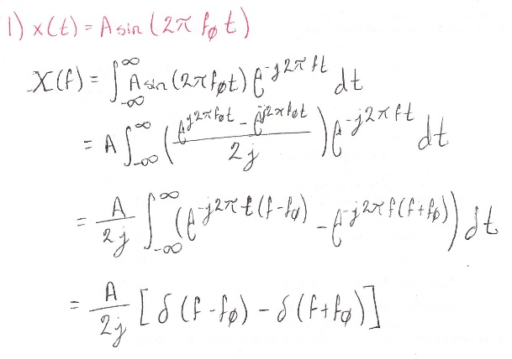 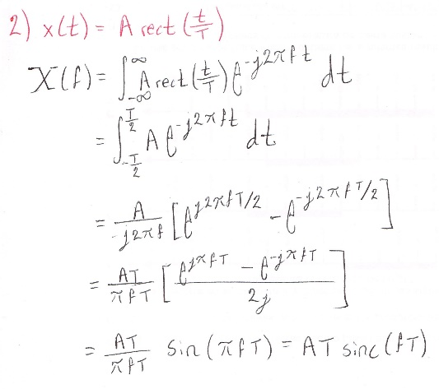

***Figure 1.*** *Fourier Transform of a sine wave.* ***Figure 2.*** *Fourier Transform of a pulse.*

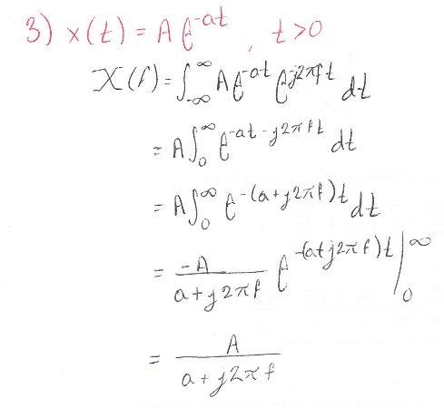 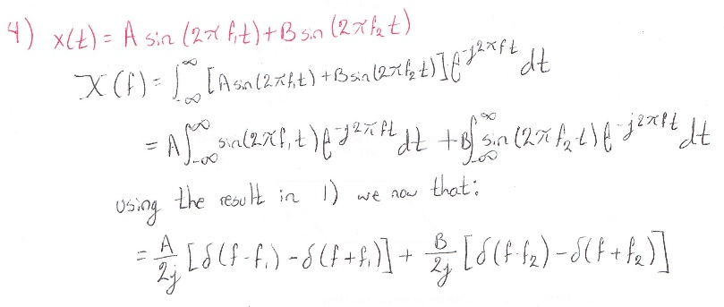

***Figure 3.*** *Fourier Transform of an exponential function* ***Figure 4.*** *Fourier Transform of a sum of sine waves.*

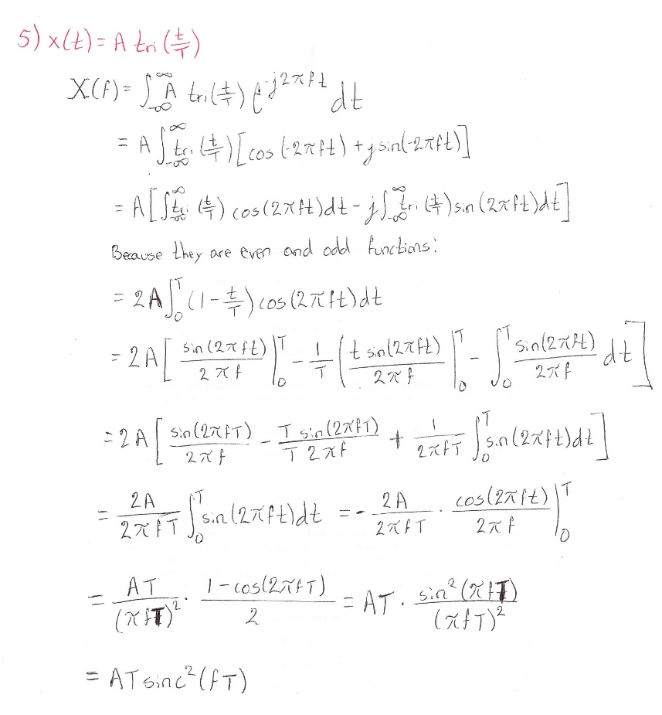

***Figure 5.*** *Fourier Transform of a triangular function.*

In the figures 6 to 10 we show the graphics of the given functions in time and frequency domain:

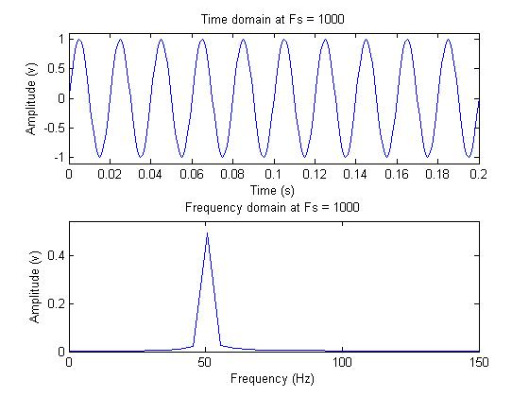

***Figure 6.*** *Time and frequency domain of a 50 Hz sine wave*

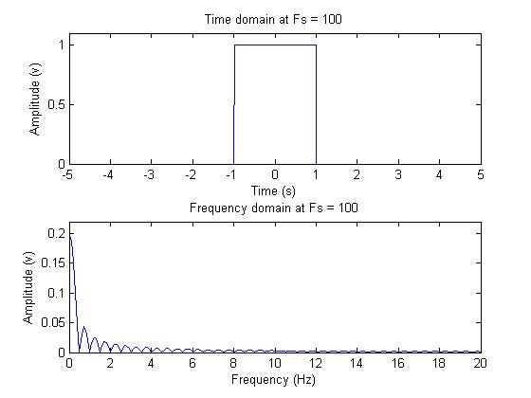

***Figure 7.*** *Time and frequency domain of a pulse of T = 2.*

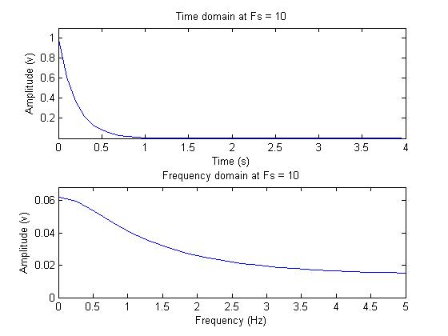

***Figure 8.*** *Time and frequency domain of a exponential function.*

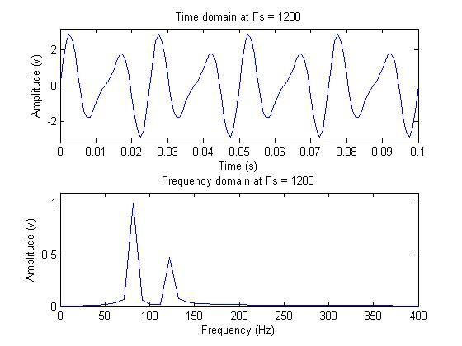

***Figure 9.*** *Time and frequency domain of a sum of sine waves at 80 Hz and 120 Hz*

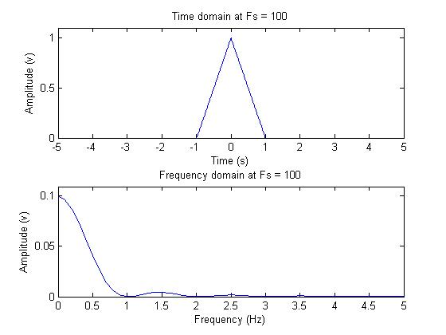

***Figure 10.*** *Time and frequency domain of a triangular function of T = 1*

***CONCLUSION:***

We corroborated the FFT function as an accurate approximation of the Fourier Transform. The FFT is a useful tool when we have discrete signals (like the ones that we got form any digital sampling). But we have to notice that it is still an approximation and it have some errors. The most noticeable difference compared with the theoretical analysis is shown in the sine wave and sum of sines where we should only see one or two delta of Dirac respectively but instead we can see how the graph approaches those values gradually.

We can convert between time domain and frequency domain when needed. The use of one of them depends on the application we have to do. It’s important to consider that, in programming, we lost some precision in every conversion due to the limits of the type of variable we use and the space in memory each one can handle.

We reaffirm the concept of the sampling theorem and the use of a correct sampling frequency. This prevented aliasing effect.

***REFERENCES:***

1. J.F James, A student’s Guide to Fourier Transforms, Third Ed., Cambridge, New York, 2011.
2. Brad G. Osgood, EE261 - The Fourier Transform and its Applications, Computer Science Department, Stanford University. Recovered from:

<http://videolectures.net/stanfordee261f07_fourier_transform/> [27/09/15]

1. J. Scott Tyo, Linear Systems, Fourier Transforms, College of Optical Sciences, The University of Arizona. Recovered from:

<http://www.optics.arizona.edu/academics/course/opti-512r> [27/09/15]

1. Lecture 7 - The Discrete Fourier Transform,

<http://www.robots.ox.ac.uk/~sjrob/Teaching/SP/l7.pdf> [27/09/15]